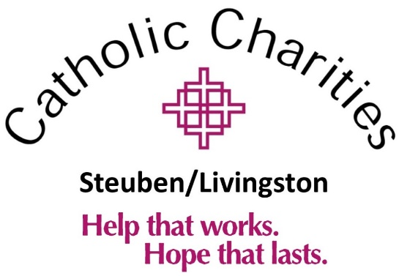
“Farm to Table” Raffle
In support of Emergency Services in Steuben & Livingston Counties

Opportunities to Support CCS/L
Your donation supports a Critical Mission:
Helping People Become Self-Sufficient

We’re raffling off a variety of meat packages as well as other prizes in support of our Emergency Services throughout Steuben and Livingston Counties. We’re partnering with Fire Creek Farms to put together some exciting packages, and with the help of Donors (like you!) we’re hoping to cover all the winning prizes. That way, ALL proceeds will go directly back to essential services in our community.

**See attached form to purchase a sponsorship**
**Completed forms can be returned to Mary Jo Strong at Maryjo.strong@dor.org or mailed to
34 E. State Street, Mt Morris NY 14510

Farm to Table Raffle
In support of Emergency Services in Steuben & Livingston Counties

Opportunities to Support CCS/L
Your sponsorship supports a Critical Mission:
Helping People Become Self-Sufficient

Sponsorship Opportunities

$1,000 Sponsorship includes:
- Premier placement on all printed promotional materials
- Shout-out in our live Facebook videos, including the final raffle drawing
- Logo posted on social media, website and email blasts
- Business spotlight in one of our monthly email newsletters

$500 Sponsorship includes:
- Logo posted on social media, website and email blasts
- Shout-out in our live Facebook videos, including the final raffle drawing
- Name included on all printed promotional materials

$250 Sponsorship includes:
- Logo posted on social media, website and email blasts

$100 Sponsorship include:
- A shout-out on social media!
Donation Items Needed:
Grills, Grill Accessories, Coolers, Adirondack Chairs, Outdoor Games

**See attached form to purchase a sponsorship**
**Completed forms can be returned to Mary Jo Strong at Maryjo.Strong@dor.org or mailed to
34 E. State Street, Mt Morris NY 14510

Farm to Table Raffle
In support of Emergency Services in Steuben & Livingston Counties

Choose a Sponsorship Option:

_____$1,000 _____$500 _____$250 _____$100

Donation Item:

Name:_______________________________Company:_____________________________________

Address:____________________________________________________________________________

Tel:________________________________Email:_____________________________________
_____Check enclosed. Make checks payable to Catholic Charities Steuben/Livingston
Please remit payment to Catholic Charities Steuben/Livingston 34 East State Street Mt. Morris, NY 14510

_____Please charge my credit card:
Card No:__________________________ Exp. Date:______________ CVV Code:__________
Name on Card:____________________________________________ Signature:________________________________________________

Or pay online at ccsteubenlivingston.org
Please contact Mary Jo with questions or for more information at Maryjo.Strong@dor.org or 585-519-2417

