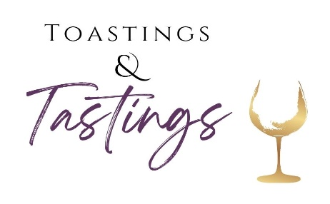

Catholic Charities Steuben/Livingston
Toastings & Tastings Event
In Honor of Fr. Lew
April 12, 2024
The Radisson Hotel – Corning

Catholic Charities Toastings & Tastings
Your GIFT supports a Critical Mission:
Helping People Become Self-Sufficient

We are so excited to announce we will be returning to The Radisson, for a party you won’t want to miss! Guests can enjoy samplings from local wineries, breweries, and even distilleries, a delicious chocolate sampling table, tasty hors d’oeuvres, and of course, a silent auction with donations from many wonderful establishments.
Our last event had over 80 donors to our silent auction, and we want to make this year bigger and better than ever! We hope you will be a part of our auction and join us for a great night of celebration…that’s long overdue!!
On behalf of CCS/L, as well as the thousands of clients whom we assist throughout the county, we thank you for your continued support.

*As a donor you will receive recognition at our event and will be listed in our event program. Please see attached product donation form if you would like to make a donation.
For more information, please contact Mary Jo Strong at (585)519-2417
or Maryjo.Strong@dor.org

Opportunities to Support CCS/L

April 12, 2024
The Radisson Hotel
Corning, NY

Silent Auction Donation Form

Date: _____________

Contact Information

 Ms. Mrs. Mr. Dr. Rev. Other ____________

Name _________________________________________________________
Title _____________________________________________________________________
Company __________________________________________________________________
Address ___________________________________________________________________
City/State/Zip________________________________________________________________
Phone Number_______________________ E-mail _________________________________

Description of donated product:
____________________________________________________________________________________________________________________________________________________________________________________________________________________________________________________________________________________________________

Value of Your Donation $_______________________________

Please Return this form by February 24th to:
Mary Jo Strong
Catholic Charities Steuben/Livingston
34 East State St., Mt Morris, NY 14510
Maryjo.Strong@dor.org
585-519-2417
585-658-2513 Fax

THANK YOU FOR YOUR SUPPORT! YOUR DONATION WILL BE FEATURED IN OUR SILENT AUCTION AND ADVERTISED IN THE PROGRAM AND SOCIAL MEDIA.

Catholic Charities Toastings & Tastings Event
See you there on April 12, 2024
at The Radisson Hotel—Corning, NY

Available Sponsorship Options:
___Reaching Goals $1,000 ____Inspiring Confidence $500
___Giving Promise $250
____________________________________________________________
____Program Ad: ____1/2 Page($100) ____1/4 Page or business card($50)
*Please provide business card/logo/info for ad

Product/Item(s) Sponsorship_____________________________________

___I am unable to purchase a sponsorship package; I have included a donation to support your great work:______________________________________
Questions? Please contact Nicole at Nicole.Ricker@dor.org Or call 585-658-4466

CONTACT INFORMATION:
Name:_______________________________Company:_______________________________________
Address:_____________________________________________________________________________
Tel: _________________________________Email: _________________________________________

_____Check enclosed. Make checks payable to Catholic Charities Steuben/Livingston
Please remit payment to Catholic Charities Steuben/Livingston 34 East State Street Mt. Morris, NY 14510
_____Please charge my credit card:
Card No:__________________________ Exp. Date:______________ CVV Code:________________
Name on Card:____________________________________________
Signature:________________________________________________
Or pay online at ccsteubenlivingston.org

