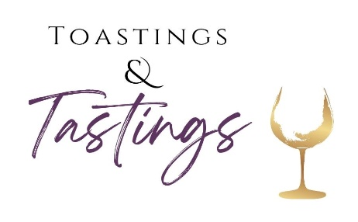

Catholic Charities Steuben/Livingston
Toastings & Tastings Event
In Honor of Fr. Lew
April 12, 2024
The Radisson Hotel – Corning

Your sponsorship supports a Critical Mission:
Helping People Become Self-Sufficient
We are so excited to announce we will be returning to The Radisson, for a party you won’t want to miss!
We are pleased to offer new and exciting sponsorship packages as well as ad purchase options for our event program.
Event sponsors receive:
· preferred ad placement in the Event Program Book
· name/logo identification on CCS/L’s website & social media and
· targeted recognition at the event!

We ask you to look at the exciting packages and consider one that would fit your budget and marketing goals. On behalf of CCS/L, as well as the thousands of clients whom we assist throughout the county, we thank you for your continued support.
For more information, please contact Nicole Ricker at (585)658-4466
or Nicole.Ricker@dor.org

Opportunities to Support CCS/L

Sponsorships
$1,000 “Reaching Goals”
Your Sponsorship Includes:
Formal Recognition at Event as a Premier Event Sponsor ∙ Print/Electronic Advertising ∙ Program Book Listing and Ad Placement ∙ Logo on CCS/L Website

$500 “Giving Promise”
Your Sponsorship Includes:
Formal Recognition at Event ∙ Print/Electronic Advertising · Program Book Listing and Ad Placement ∙ Logo on CCS/L Website

$250 “Inspiring Confidence”
Your Sponsorship Includes:
Formal Recognition at Event ∙ Print/Electronic Advertising · Program Book Listing and Ad Placement ∙ Logo on CCS/L Website

Purchase an Ad in our Event Program:
$100 for a half page ad
$50 for a quarter page ad (business card size)
~Please provide info/logo/business card to be included in the ad, all pictures should be in .jpg or .png format~

**See attached form to purchase an ad/sponsorship**
**Completed forms can be returned to Nicole Ricker at Nicole.Ricker@dor.org or mailed to 34 E. State Street, Mt Morris NY 14510
For questions contact Nicole at 585-658-4466

Catholic Charities Steuben/Livingston is a non-profit organization. Under section 501©(3) of the IRS code, sponsorships are tax-deductible to the fullest extent allowed by law. For more information, please visit ccsteubenlivingston.org
Catholic Charities Toastings & Tastings Event
See you there on April 12, 2024
at The Radisson Hotel—Corning, NY

Available Sponsorship Options:
___Reaching Goals $1,000 ____Inspiring Confidence $500
___Giving Promise $250
____________________________________________________________
____Program Ad: ____1/2 Page($100) ____1/4 Page or business card($50)
*Please provide business card/logo/info for ad

Product/Item(s) Sponsorship_____________________________________

___I am unable to purchase a sponsorship package or table; I have included a donation to support your great work:______________________________________
Questions? Please contact Nicole at Nicole.Ricker@dor.org Or call 585-658-4466

CONTACT INFORMATION:
Name:_______________________________Company:_______________________________________
Address:_____________________________________________________________________________
Tel: _________________________________Email: _________________________________________

_____Check enclosed. Make checks payable to Catholic Charities Steuben/Livingston
Please remit payment to Catholic Charities Steuben/Livingston 34 East State Street Mt. Morris, NY 14510
_____Please charge my credit card:
Card No:__________________________ Exp. Date:______________ CVV Code:________________
Name on Card:____________________________________________
Signature:________________________________________________
Or pay online at ccsteubenlivingston.org

